34.108: a) 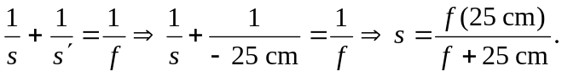
b) Height =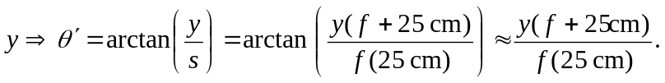
c) M=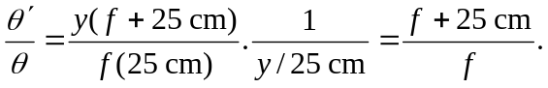
d) If 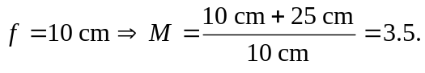This is 1.4 times greater than the magnification obtained if the image if formed at infinity 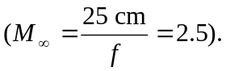
e) Having the first image form just within the focal length puts one in the situation described above, where it acts as a source that yields an enlarged virtual image. If the first image fell just outside the second focal point, then the image would be real and diminished.

